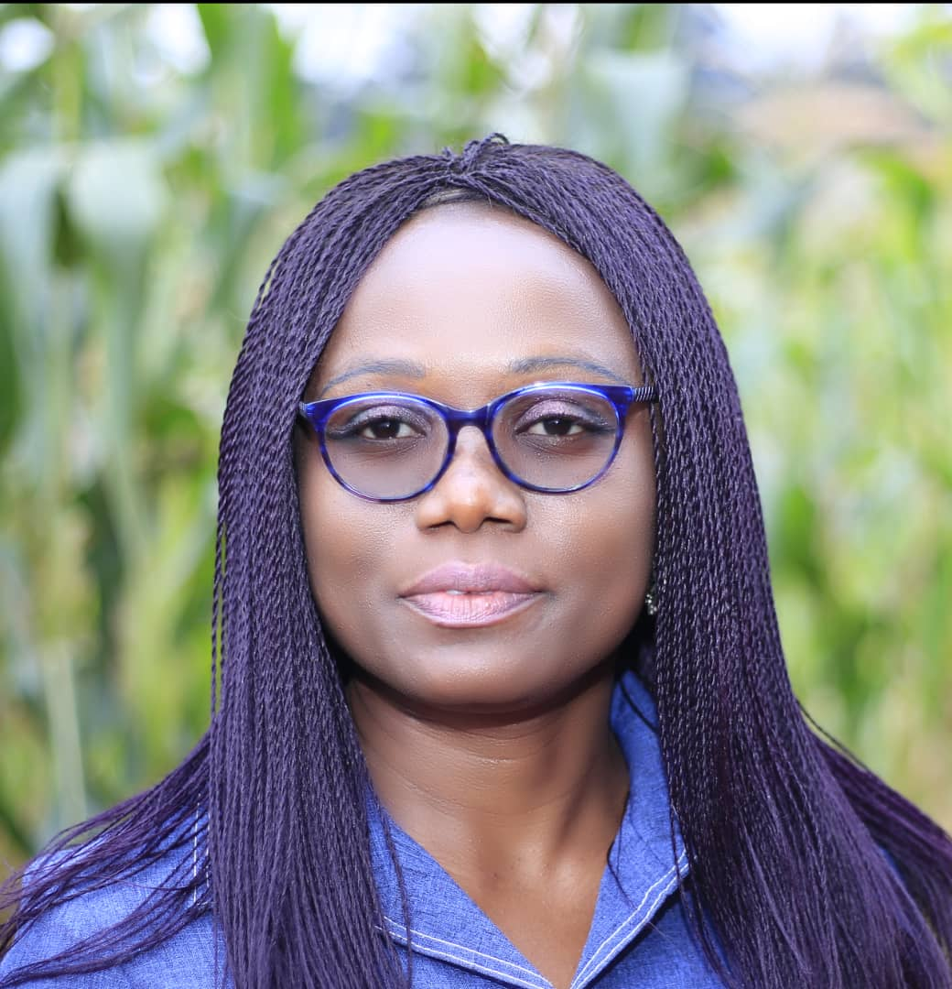
Dr NZWEUNDJI Justine Germo is a Plant Biotechnologist and researcher at the Institute of Medical Research and Medicinal Plants Studies (IMPM)/ Ministry of Scientific Research and Innovation. Her research interest is tissue culture of medicinal plants for better domestication and production of secondary metabolites. She received the prestigious fellowship Unesco-l’Oréal for her PhD research in US at Tropical Research and Educational Center, University of Florida in 2011 and at Alabama A&M University in 2013. She received many grants and prizes and in 2015 the prize of the best junior researcher of IMPM. Since 2017, she is a member of the steering committee INGSA-Africa. She also has been involved in training and supervising many students for their internship and their Master’s Thesis. In early 2018, she received a postdoctoral research fellow at Geisenheim Hoschule University in Germany through TWAS-DFG. She is a cohort 5 of the African Science Leadership Programme 2019. She is actually the President of the Cameroon Academy of Young Scientists and member of the Global Young Academy.

